DAYANANDA SAGAR UNIVERSITY
Kudlu Gate, Bengaluru-560068



A MINI-PROJECT REPORT
ON
“MUSICAL SCALE/RAGA DETECTION USING MATLAB”

Submitted by
NITHIN N ENG18EC0072
PRASAD M S ENG18EC0078
PRATYUSHA B R ENG18EC0080
To,
MANASA K R
Assistant Professor

Department of Electronics & Communication Engineering
School of Engineering
2020-2021

DAYANANDA SAGAR UNIVERSITY
School of Engineering
Kudlu Gate, Bengaluru-560068
Department of Electronics & Communication Engineering
CERTIFICATE

Certified that the mini-project work entitled “MUSICAL SCALE/RAGA DETECTION USING MATLAB” is a bonafide work carried out by
NITHIN N ENG18EC0072
PRASAD M ENG18EC0078
PRATYUSHA B R ENG18EC0080

The report has been approved as it satisfies the academic requirements in respect of mini-project work prescribed for the course.

……………………… …………………………
Manasa K R Dr.Vaibhav A Meshram
DSP Course Coordinator (5A) Chairman

TABLE OF CONTENTS:

ABSTRACT

INTRODUCTION

LITERATURE SURVEY

PROBLEM STATEMENT

DESIGN (DATABASE, PITCH NAMING FUNCTION, AUTOCORRELATION FUNCTION, (CHARACTERISTIC OF AUTOCORRELATION FUNCTION))

RESULT AND ANALYSIS

ADVANTAGES

CONCLUSION AND FUTURE WORK

REFERENCES

ABSTRACT:
Music is one of the fast-growing industries in today's world and faces many difficulties. Indian Classical music, too, is different from other western music patterns and difficult to learn or identify. A lot of work has been done before using traditional approaches and expertise to identify ragas with the help of standard features such as arohana, avarohana, pakad, gamak, vaadi, savandi etc. but with the help of new features such as chromagrams, we have tried a new approach. After extraction, storage and data training with the help of a Autocorrelation function in MATLAB.

INTRODUCATION:
Indian classical music is different from that of western music. Raga plays an important role in classical Indian music. Raga consists of different characteristics that are not easy to extract or mine by applying an approach that is used to identify western music. Some properties of raga may be lost by this. There is therefore a need for different data mining techniques to identify raga. So, apart from the traditional approach of collecting different notes that have some special properties (e.g. arohana, avarohana, pakad, taal, etc.), we have tried to use different techniques and different features. Raga is divided into two systems of Hindustani (North Indian) music, Carnatic (South Indian) music [1]. Both systems differ in their characteristics and performance. Raga is having special characteristics of their timing, that depending on their nature they can be played in different timeslots of the day. Notes of a raga arranged in an ascending order forms arohana of that raga and notes of a raga arranged in a descending order forms avarohana of that raga. In Indian classical music, different notes are called swaras. Raga identification consists of techniques that identify different notes from a piece of music and therefore classify it as appropriate raga. By using our different features discussed further, we have tried to achieve new heights.
- Sound wave is made up of vibrations
- Each note is represented by Sa Ri Ga Ma Pa Da Ni Sa(Indian) or C D E F G A B C(Western)
- Including the semitones there are 12 main note i.e
"S","R1","R2","G2/R3","G3","M1","M2","P","D1","D2/N1","N2/D3","N3","S"
- There are 72 Melakartha ragas in Carnatic music
- This Swara is nothing but frequency
- Ex: A4= 440Hz A5= 880Hz

LITERATURE SURVEY:
In existing systems, work to date has been done on the basis of a static level using the characteristics of raga. Raga is identified on the basis of its fundamental characteristics: Arohana-Avarohana, Pakad, Gamakas, Swara Choice, Vadi, Time and Season, etc. These characteristics help to analyze and frame different computational techniques for the identification of raga. Pandey etc. [2]. It provides approximately 70 percent-80 percent accuracy with respect to the ML algorithm data set. Also, these methods are not real tome methods. A brief introduction to raga is being discussed. Characteristics of raga that make them sufficient to be distinguishable from each other. Different techniques are better than other techniques depending on the input parameters and the restriction on the input and the method. Limited database containing a limited number of ragas. Incorrect extraction of pitch. Manual detection of tonic. Assumption has been made for different algorithm parameters. Various restrictions on inputs, such as limitation on singers, number of swaras, length of time, monophonic type. No machine learning techniques have been used [1]. Note on this Prefer method, which is independent of input parameters. Provide a large amount of dataset to obtain a better and more accurate result. Try to combine 2 techniques, n-gram & pitch-class profiles in order to get a better result than other classical methods. Comp-Music dataset and our own dataset show that the combination of pitch-class profiles and n-gram histograms actually improves performance. The best accuracy of our approach is 83.39 per cent. It is limited to only 4 to 5 ragas. There are problems with the classifiers and the pitch profile class. The combination of male and female voice as well as many other instruments may affect the accuracy of the result [2]. Remark on this paper uses combinations of techniques that provide better results and accuracy than conventional methods. The combination of different voices and instruments may lead to a wrong result. Incorrect extraction of pitch. Manual detection of tonic. Assumption has been made for different algorithm parameters. Various restrictions on inputs, such as limitation on singers, number of swaras, length of time, monophonic type. There are no machine learning techniques used. Only the static work is done through identification [3]. Remark on this paper is the lack of a database and the incorrect extraction of features results in an incorrect result. Machine learning is going to provide a better result. Assumption could go wrong. Using a classifier we can identify raga, so that we can correlate this raga with its respective rasa to identify emotions in music. For a better result, more comprehensive dataset is needed for the K-NN classifier. We can only get approximate values by using soft computing techniques such as fuzzy logic. The SVM classifier is difficult to handle scale and multiple instruments. K-NN may cause problems with gammakas and pitch extraction. Classifier of Naïve Bayes, the identification of raga is very difficult and gives less accuracy [7]. Remark on this paper is that soft computing techniques are used to archive results. The classifiers used have limitations on the results and the extracting features. The algorithms used give the most accurate result for two types of ragas. The system needs to be improved with the Hidden Markov model. Based approach where we combine the features of low levels. And HMM for better and more accurate identification. Singers and audios are only specific and limited. Limited test data may lead to a misleading decision. This one. The basic disadvantage of the system is the assumption of the fundamental frequency and therefore the determination of the fundamental frequency is our next task[8]. Review of this paper is a new "Hidden Markov" method used to improve the outcome. The result is limited by different singers and styles. Fundamental frequencies are considered as one of the disadvantages due to inaccuracy.

PROBLEM STATEMENT:
It is quite difficult to identify ragas in Indian classical music. Since it has several features and parameters, it is not easy to recognize ragas in music. The identity of each raga varies, and each has its own speciality that needs to be maintained. In addition, Hindustani music is highly improvised as a performer enjoys full freedom for any raga movement that leads to misclassification errors.

DESIGN:
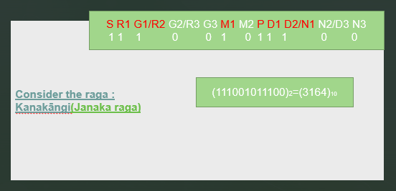
Fig.1 Creating Database using Binary Weights

DATABASE:
- name=["kanakangi","ratnangi","ganamoorti","vanaspati","manavati","tanaroopi","senavati","hanumatodi","dhenuka","natakapriya","kokilapriya","rupavati","gayakapriya","vakulabharanam","mayamalava gowla","chakravakam","sooryakantam","hatakambari","jhankaradhvani","natabhairavi","keeravani","kharaharapriya","gowri manohari","varunapriyaa","mararanjani","charukeshi","sarasangi","harikambhoji","dheera shankarabharanam","naganandhini"];

- values=[3164,3162,3161,3158,3157,3155,3420,3418,3417,3414,3413,3411,3292,3290,3289,3286,3285,3283,2908,2906,2905,2902,2901,2899,2780,2778,2777,2774,2773,2771];
Here we created database for 30 Melakarta ragas out of 72 main ragas. And also we can create more for better efficiency.

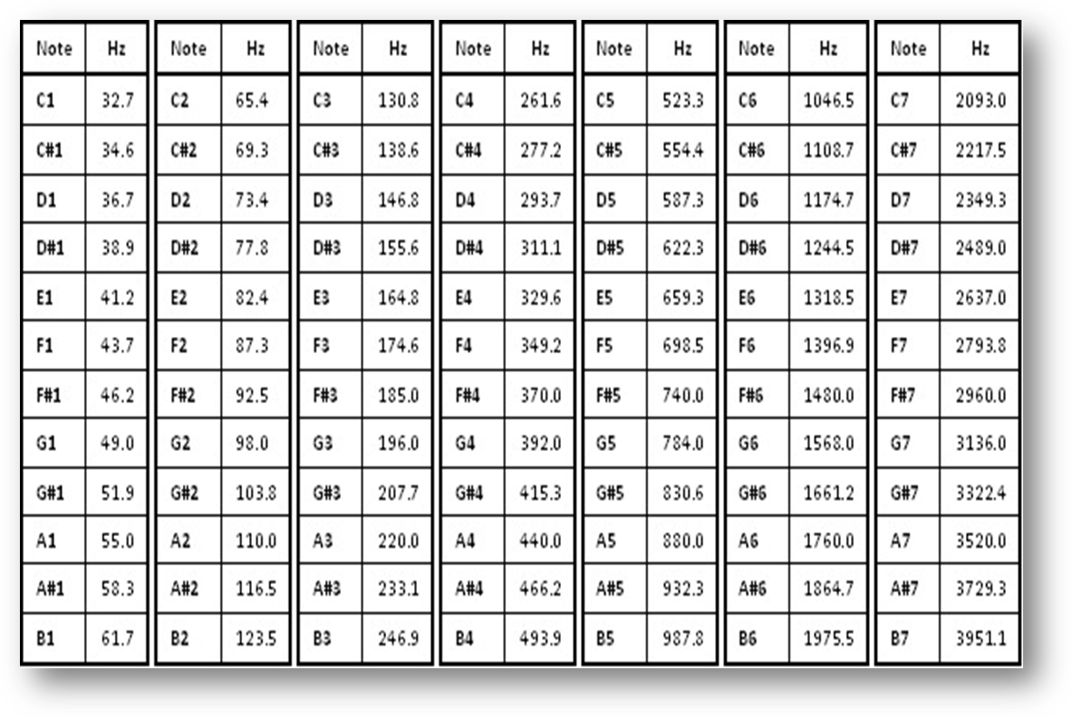
Fig.2 Frequencies of Notes/Swaras

PITCH NAMING FUNCTION:
- The ratio of adjacent notes in piano is 2*(1/12)
- The frequency change in piano is in geometric series
- The standard frequency reference is
- A=440Hz
- Hence to find the notation we use
- function [y,n]=pitchname(f)
- Notation=["A","A#","B","C","C#","D","D#","E","F","F#","G","G#","A"];
- n=log2(f/440)*12;
- n=round(abs(mod(n,12)))+1;
- y=Notation(n)+join(string(floor(f/440)+4));
- end

FINDING PITCH USING AUTOCORRELATION FUNCTION:
CHARACTERISTICS OF AUTOCORRELATION FUNCTION:
It has highest amplitude at the origin
The difference between the two prominent peaks gives the time period.
T=tp(1)-tp(2)
F=1/t

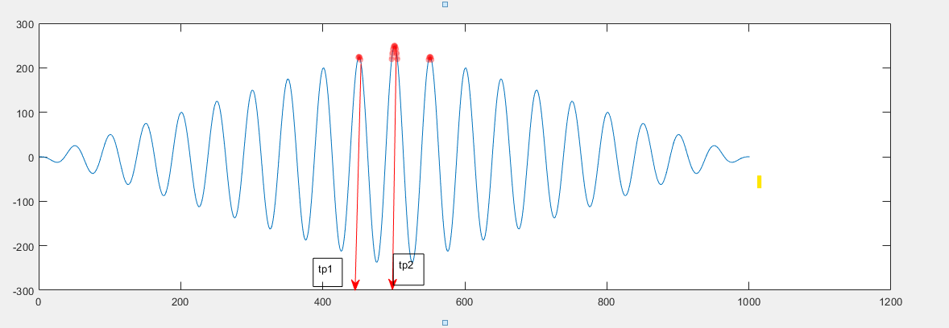
Fig.3 finding pitch of raga using autocorrelation function

RESULT AND ANALYSIS:

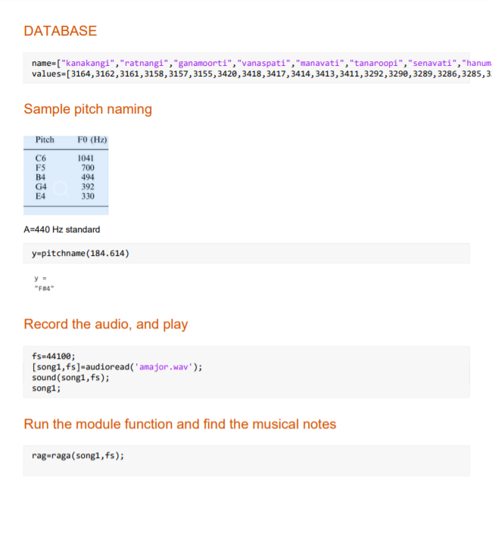

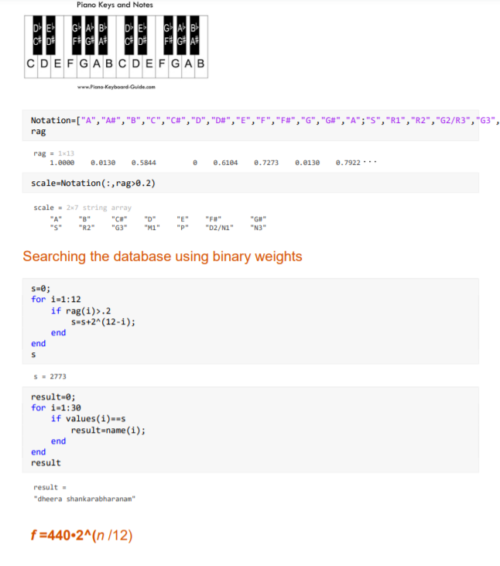

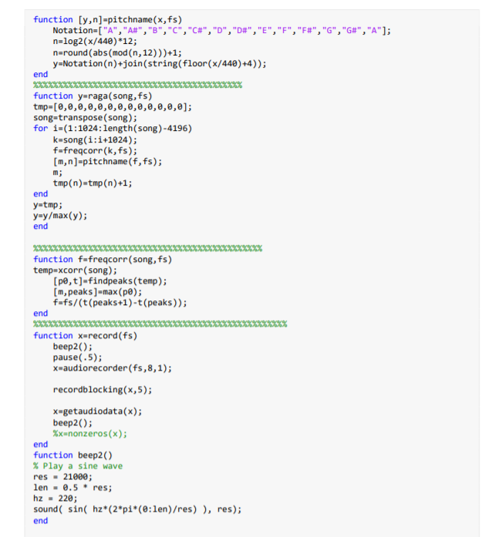

APPLICATION:
Allows user to search for a raga from its Swaras(notes)
It also provides Arohana(Ascending scale) and Avarohanm(Descending scale) for each raga.

CONCLUSION AND FUTURE WORK:
A brief introduction to raga and its characteristics is discussed. Previous techniques for the identification of raga are investigated with their data set, details of the implementation method, accuracy and issues. Techniques differ from one another with differences in their data set, method of implementation, parameters, accuracy and limitations. Different techniques are better than other techniques depending on the input parameters and the restriction on the input and the method. In addition, Hindustani music is highly improvised as a performer enjoys full freedom for any raga movement that leads to misclassification errors. Fluctuations in human voice while performing live are taken into account and this has affected the accuracy of our work.

REFERENCES:
https://en.wikipedia.org/wiki/List_of_Janya_rag
https://en.wikipedia.org/wiki/Piano_key_frequenciesas

